**MAR -17 DEVOPS TRAINING**

**TASK :** Install Postgres Database

Create A Database

Create a User

Get Database Connection

Count Of Users / Database Size

**\*Install Postgres Database**

1. Add Postgresql Repository

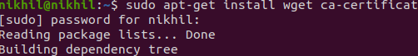

1. Update the package list





1. Install Postgresql



### **Check Available PostgreSQL Version**

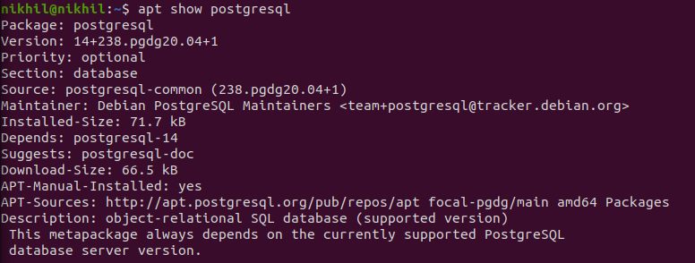

### **Install PostgreSQL Package**

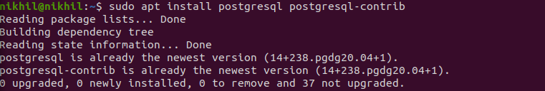

## **Connect to PostgreSQL**

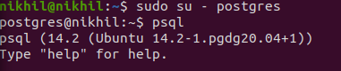

## **Check Connection Information**

**>>Created a Database**

**>> Created a user**

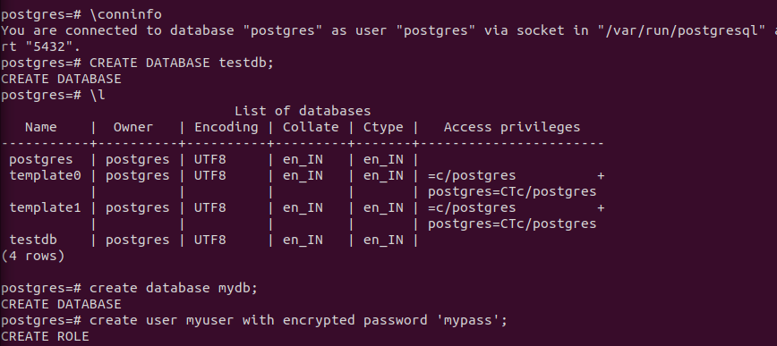

Get DB connection



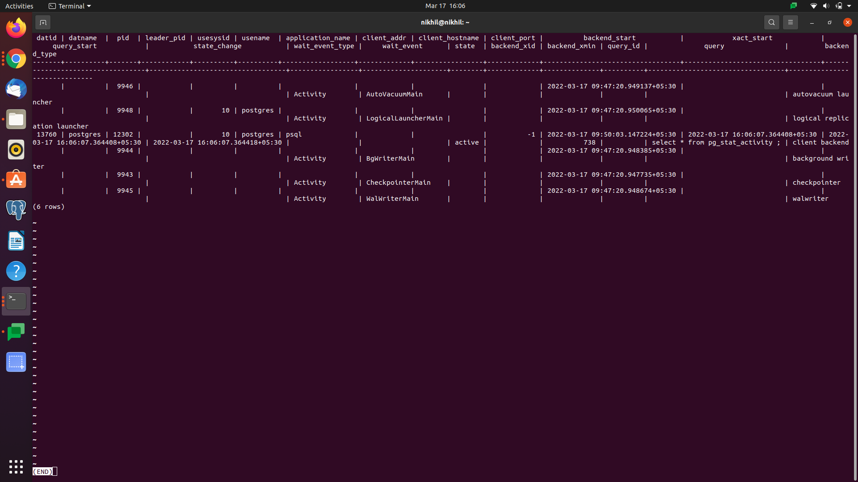

5) Count and DB size



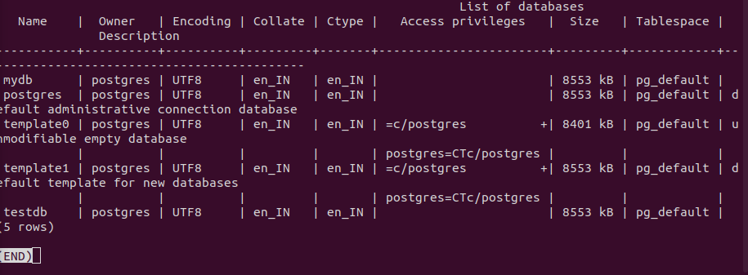

References

<https://phoenixnap.com/kb/how-to-install-postgresql-on-ubuntu>

<https://www.guru99.com/postgresql-create-database.html>

<https://www.tutorialspoint.com/postgresql/postgresql_create_database.htm>

<https://medium.com/coding-blocks/creating-user-database-and-adding-access-on-postgresql-8bfcd2f4a91e>

<https://www.digitalocean.com/community/tutorials/how-to-install-and-use-postgresql-on-ubuntu-20-04>